Grafana Installation

https://computingforgeeks.com/how-to-install-grafana-on-ubuntu-linux-2/

sudo apt update

sudo apt-get install -y gnupg2 curl software-properties-common

curl https://packages.grafana.com/gpg.key | sudo apt-key add -

sudo add-apt-repository "deb https://packages.grafana.com/oss/deb stable main"

sudo apt update

*#You might get public key error when you perform above command. We can resolve this by running below comamnd with the key given in the error*

sudo apt-key adv --keyserver keyserver.ubuntu.com --recv-keys 8C8C34C524098CB6

sudo add-apt-repository "deb https://packages.grafana.com/oss/deb stable main"

sudo apt-get update

sudo apt-get -y install grafana

sudo systemctl enable --now grafana-server

sudo /bin/systemctl start grafana-server

sudo /bin/systemctl status grafana-server --no-pager

Access Grafana Dashboard on http://<ip>:3000 admin/admin

Linux Hosts Metrics | Base

<https://grafana.com/grafana/dashboards/10180>

<https://grafana.com/grafana/dashboards/14282-cadvisor-exporter/>

Import Dashboard 11600

https://grafana.com/grafana/dashboards/14282-cadvisor-exporter/

Install cAdvisor using below Docker Command:

ansible -i invfile pvt -m shell -a 'sudo docker run \

--volume=/:/rootfs:ro \

--volume=/var/run:/var/run:ro \

--volume=/sys:/sys:ro \

--volume=/var/lib/docker/:/var/lib/docker:ro \

--volume=/dev/disk/:/dev/disk:ro \

--publish=8080:8080 \

--detach=true \

--name=cadvisor \

--privileged \

--device=/dev/kmsg \

gcr.io/cadvisor/cadvisor:v0.36.0'

ansible -i invfile pvt -m shell -a "docker ps"

Grafana SSL Configuration:

Copy crt and key to /etc/grafana

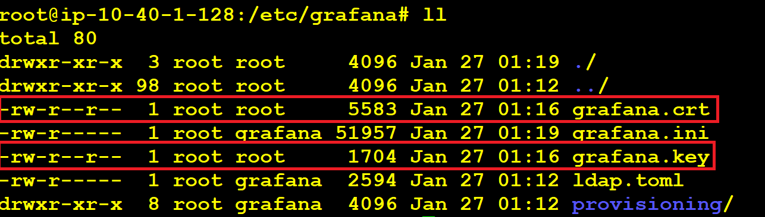

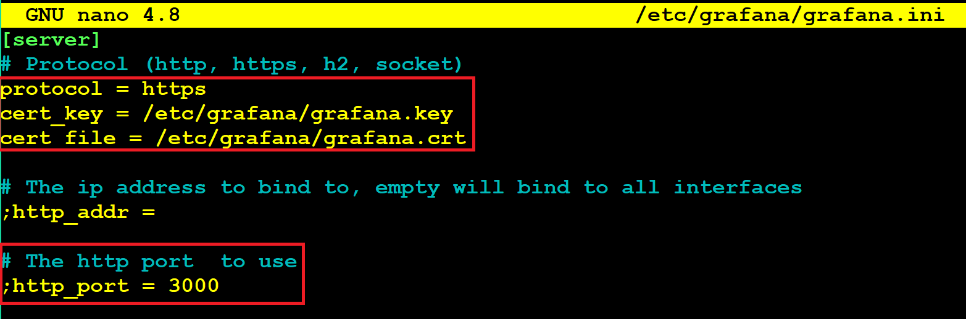



sudo /bin/systemctl restart grafana-server

sudo /bin/systemctl status grafana-server

